Boardmaker Literacy Supports

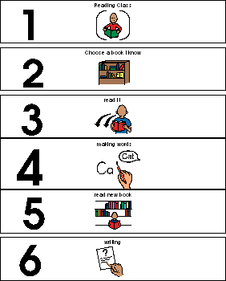
Visual Schedule for Literacy Lesson
________________________________________________

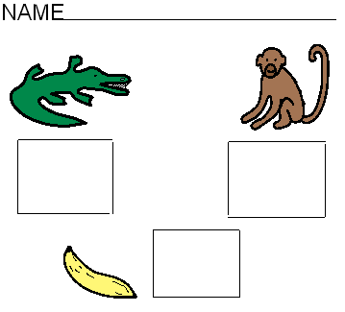

Recognizing/matching beginning sounds from: “What Time is it Mr. Crocodile?”

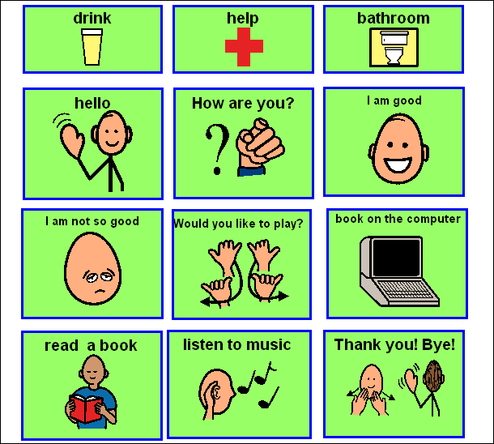
Recess Routine Overlay for Go Talk 9 including Literacy Activities
_______________________________________________

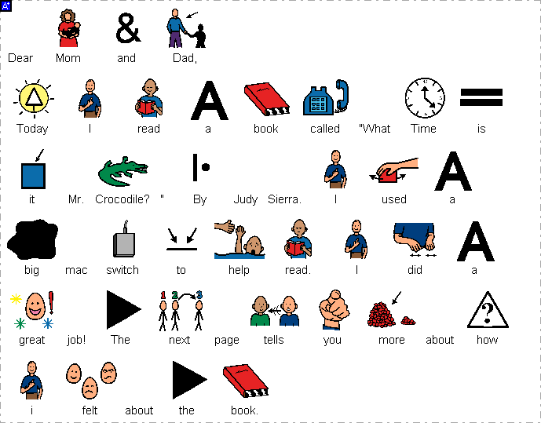
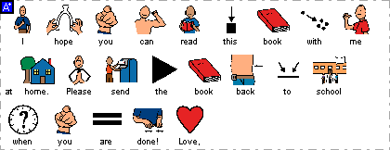
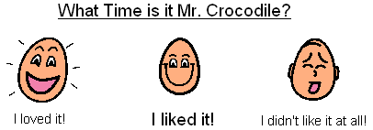

Note Home and Reader’s Response (point or use bingo dabber)
________________________________________________

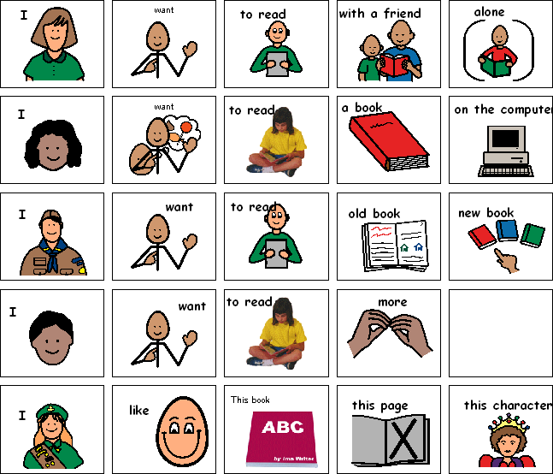

Literacy Choices and Reader’s Responses
________________________________________________

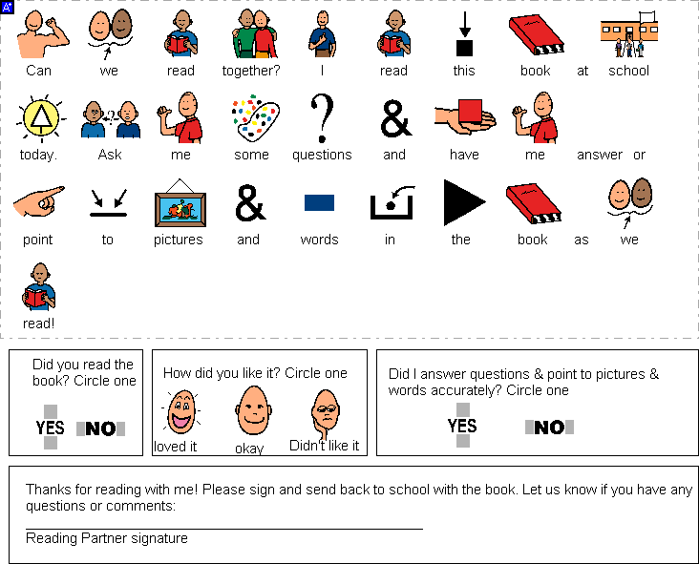

Parents as Reading Partners/ Note Home/Reader’s Response

Name_____________________________
Combine a blend and an ending to make a word that matches the picture. Write the word on the line below or cut and paste the words.

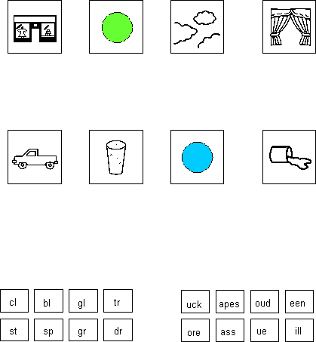
Sample Word Work Activity
Beginning Blends Endings

